**ZÁKLADNÁ ŠKOLA S MATERSKOU ŠKOLOU KUCHYŇA**

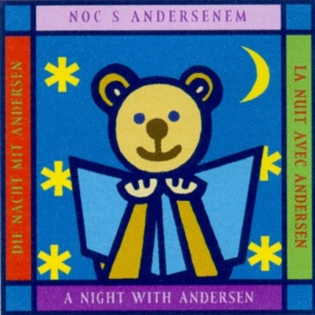

[](https://www.google.sk/imgres?imgurl=http://rosenfeldovpalac.sk/wp-content/uploads/2016/10/cropped-hviezda.png&imgrefurl=http://rosenfeldovpalac.sk/cropped-hviezda-png/&docid=F9AdGI365JliqM&tbnid=8Oyk5em_PKCAFM:&vet=10ahUKEwj9zqX66OTZAhXLBSwKHWD1AZkQMwhUKBYwFg..i&w=512&h=512&bih=641&biw=1280&q=hviezda&ved=0ahUKEwj9zqX66OTZAhXLBSwKHWD1AZkQMwhUKBYwFg&iact=mrc&uact=8)

[](https://www.google.sk/imgres?imgurl=http://rosenfeldovpalac.sk/wp-content/uploads/2016/10/cropped-hviezda.png&imgrefurl=http://rosenfeldovpalac.sk/cropped-hviezda-png/&docid=F9AdGI365JliqM&tbnid=8Oyk5em_PKCAFM:&vet=10ahUKEwj9zqX66OTZAhXLBSwKHWD1AZkQMwhUKBYwFg..i&w=512&h=512&bih=641&biw=1280&q=hviezda&ved=0ahUKEwj9zqX66OTZAhXLBSwKHWD1AZkQMwhUKBYwFg&iact=mrc&uact=8)NOC [](https://www.google.sk/imgres?imgurl=http://rosenfeldovpalac.sk/wp-content/uploads/2016/10/cropped-hviezda.png&imgrefurl=http://rosenfeldovpalac.sk/cropped-hviezda-png/&docid=F9AdGI365JliqM&tbnid=8Oyk5em_PKCAFM:&vet=10ahUKEwj9zqX66OTZAhXLBSwKHWD1AZkQMwhUKBYwFg..i&w=512&h=512&bih=641&biw=1280&q=hviezda&ved=0ahUKEwj9zqX66OTZAhXLBSwKHWD1AZkQMwhUKBYwFg&iact=mrc&uact=8)S ANDERSENOM[](https://www.google.sk/imgres?imgurl=http://rosenfeldovpalac.sk/wp-content/uploads/2016/10/cropped-hviezda.png&imgrefurl=http://rosenfeldovpalac.sk/cropped-hviezda-png/&docid=F9AdGI365JliqM&tbnid=8Oyk5em_PKCAFM:&vet=10ahUKEwj9zqX66OTZAhXLBSwKHWD1AZkQMwhUKBYwFg..i&w=512&h=512&bih=641&biw=1280&q=hviezda&ved=0ahUKEwj9zqX66OTZAhXLBSwKHWD1AZkQMwhUKBYwFg&iact=mrc&uact=8)

[](https://www.google.sk/imgres?imgurl=http://rosenfeldovpalac.sk/wp-content/uploads/2016/10/cropped-hviezda.png&imgrefurl=http://rosenfeldovpalac.sk/cropped-hviezda-png/&docid=F9AdGI365JliqM&tbnid=8Oyk5em_PKCAFM:&vet=10ahUKEwj9zqX66OTZAhXLBSwKHWD1AZkQMwhUKBYwFg..i&w=512&h=512&bih=641&biw=1280&q=hviezda&ved=0ahUKEwj9zqX66OTZAhXLBSwKHWD1AZkQMwhUKBYwFg&iact=mrc&uact=8)23.3.2018[](https://www.google.sk/imgres?imgurl=http://rosenfeldovpalac.sk/wp-content/uploads/2016/10/cropped-hviezda.png&imgrefurl=http://rosenfeldovpalac.sk/cropped-hviezda-png/&docid=F9AdGI365JliqM&tbnid=8Oyk5em_PKCAFM:&vet=10ahUKEwj9zqX66OTZAhXLBSwKHWD1AZkQMwhUKBYwFg..i&w=512&h=512&bih=641&biw=1280&q=hviezda&ved=0ahUKEwj9zqX66OTZAhXLBSwKHWD1AZkQMwhUKBYwFg&iact=mrc&uact=8)

 [](https://www.google.sk/imgres?imgurl=http://rosenfeldovpalac.sk/wp-content/uploads/2016/10/cropped-hviezda.png&imgrefurl=http://rosenfeldovpalac.sk/cropped-hviezda-png/&docid=F9AdGI365JliqM&tbnid=8Oyk5em_PKCAFM:&vet=10ahUKEwj9zqX66OTZAhXLBSwKHWD1AZkQMwhUKBYwFg..i&w=512&h=512&bih=641&biw=1280&q=hviezda&ved=0ahUKEwj9zqX66OTZAhXLBSwKHWD1AZkQMwhUKBYwFg&iact=mrc&uact=8) o 18.00 hod v ZŠ

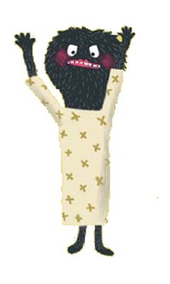 [](https://www.google.sk/imgres?imgurl=http://rosenfeldovpalac.sk/wp-content/uploads/2016/10/cropped-hviezda.png&imgrefurl=http://rosenfeldovpalac.sk/cropped-hviezda-png/&docid=F9AdGI365JliqM&tbnid=8Oyk5em_PKCAFM:&vet=10ahUKEwj9zqX66OTZAhXLBSwKHWD1AZkQMwhUKBYwFg..i&w=512&h=512&bih=641&biw=1280&q=hviezda&ved=0ahUKEwj9zqX66OTZAhXLBSwKHWD1AZkQMwhUKBYwFg&iact=mrc&uact=8) [](https://www.google.sk/imgres?imgurl=http://rosenfeldovpalac.sk/wp-content/uploads/2016/10/cropped-hviezda.png&imgrefurl=http://rosenfeldovpalac.sk/cropped-hviezda-png/&docid=F9AdGI365JliqM&tbnid=8Oyk5em_PKCAFM:&vet=10ahUKEwj9zqX66OTZAhXLBSwKHWD1AZkQMwhUKBYwFg..i&w=512&h=512&bih=641&biw=1280&q=hviezda&ved=0ahUKEwj9zqX66OTZAhXLBSwKHWD1AZkQMwhUKBYwFg&iact=mrc&uact=8)