In the previous “language corner from January” I brought you the new term AAVE – African American Vernacular English -, but I explained to you just a pinch of this variety of English. I presented you only few specific words and phrases and introduced to you the way how they create and enrich “their” language.

The English spoken by African-Americans in the U.S. differs systematically from “Standard English” (SE). Known as “Black English” (BE a term which replaces the earlier “Non-Standard Negro English”), or as “Black English Vernacular”, it has a specific grammar system. Common prejudice has it that black English is necessarily inferior to white, but this view has no linguistic validity. It is a variety of English as many others like Texas English, Cockney English in South-eastern London or Estuary English as well in the UK.

“This African American Vernacular English shares most of its grammar and vocabulary with other dialects of English. But it is distinct in many ways, and it is more different from Standard English than any other dialect spoken in continental North America.” William Labov (an American sociolinguists – he set the basics to this branch)
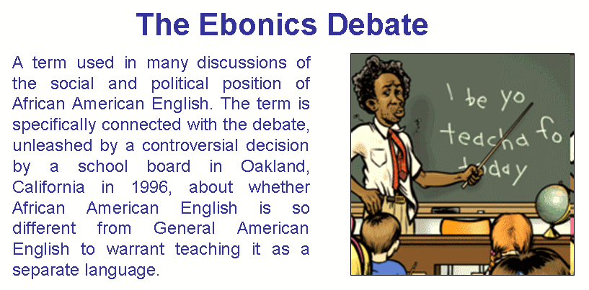

Differences in verbs

Verb stems (this can cause a misunderstanding, but don´t worry☺)

In BE the stem of many verbs is different from SE:

Not fill, but full: He fullin’ de tank
Not leave, but lef He lef town
Not heat, but hot Told to heat the beans, he ate them!
Not ask, but aks He aks me the way

Optional Past-Tense Marking

In all languages verbs can be marked for tense. Tense expresses distinctions of the position in time or duration of the action: mostly we recognize past, present, or future tenses.

In Standard English (SE), marking of verb tense is obligatory!!!

That’s the reason why we are standing upon your grammar ☺ It’s the same like doing it in standard Slovak language. Because there is the system!!!

In Black English marking of tense is optional. Such a lucky language, isn’t it? Action in the past may be represented by the base form of the verb.

SE: I fed the cat and washed the dishes and swept the floor.

In BE the following may be either present or past tense:

I feed the cat and wash the dishes and sweep the floor.

In SE verbs one by one must be marked as either present or past; in BE only one of the verbs need be marked (though more than one may be). So an alternative acceptable past-tense form would be:

I fed the cat and (BUT! Not washed) wash the dishes and (BUT! Not swept) sweep the floor

The number of verbs marked is free, it means that at least one verb must be in the past tense, the rest of verbs is up to you ☺:

The boy carried the dog dish in the house and put some food in it and bring it out and
called his dog...

Or the past tense can be shown only by some time expressions and verbs don’t have to be in the past simple form:

Yesterday, I feed the cat and wash the dishes and sweep the floor.
So ...he go yesterday... is grammatical.

Obligatory Aspect Marking
There is no use of the forms of the verb be in the present tense as a copula or ‘linking’ verb (every form of verb “be”, e.g. is, are, was, were, etc.):
They real fine If you interested

When we need to say anything in a continuous form, such as in cases like I am working. They just say: “I be working”. It can mean both the present and the past.
Or you know when the perfect tenses are hard nuts to crack and you don’t know if have/has/had is needed, the users of BE don’t beat their heads, instead of have/has they use done, so sentences look like I have gone/ I done go – so after DONE (as a feature of perfect for them) they use the base form of verb afterwards.

And there are many other exceptions or easier ways how to express what you want, but it doesn’t mean, you will stop using the correct forms of verbs. REMEMBER! This is only for extending of your knowledge about language, not to convince your teacher that you don’t have to know the language system, because there are people who don’t have to also! ☺
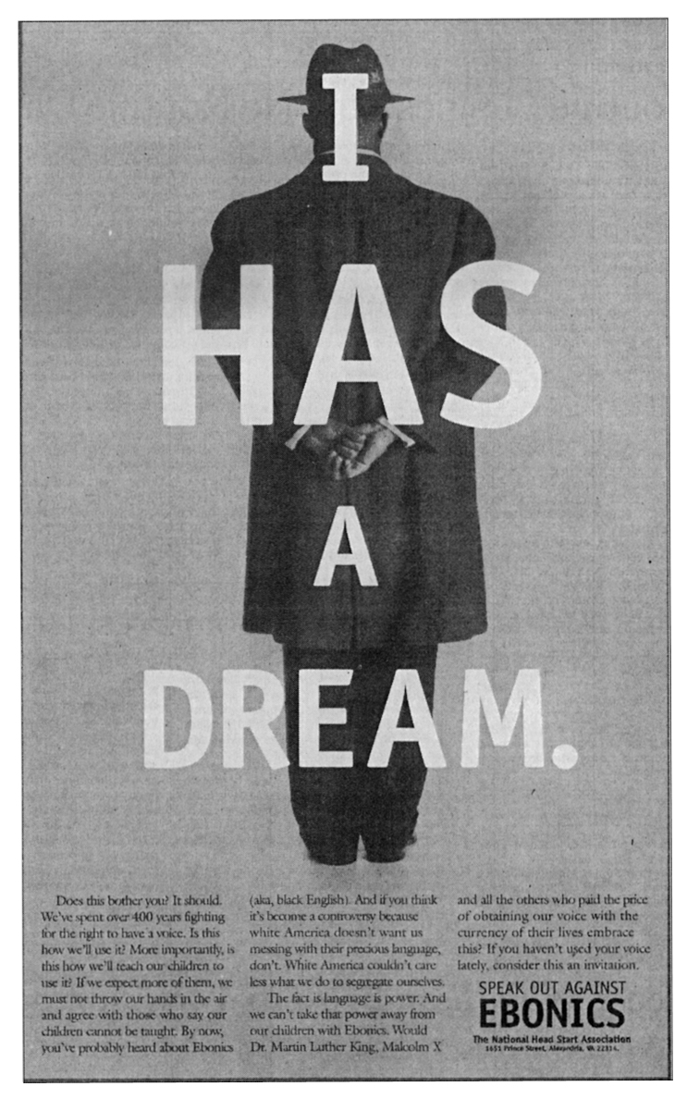
TRY TO GUESS WHO SAID IT?
(My hint to you: the greatest spokesperson and leader of the civil rights movement - M.L.K)
Try to find a difference, not a mistake.

The opposite is superior (nadradený), inferior means not good, or not as good as someone or something else (podradný, podradený)
Bez jazykovednej platnosti
A central part of a word
Standard English – spisovná forma angličtiny
It is necessary (je to nutné/povinné)
If you want, you can present the past simple, past continuous, etc.
Martin Luther King

